**Project Design Phase**

**Problem – Solution Fit Template**

|  |  |
| --- | --- |
| Date | 15 February 2026 |
| Team ID | LTVIP2026TMIDS54366 |
| Project Name | Prosperity Prognosticator: Startup Success Prediction using ML |
| Maximum Marks | 2 Marks |

**Problem – Solution Fit Template:**

The Problem-Solution Fit ensures that the identified customer problem is effectively solved by the proposed AI-based Startup Success Prediction System. The solution is designed based on real investor challenges and behavioral patterns.

**Purpose:**

**✔ Solve investment decision uncertainty using predictive analytics.  
✔ Increase solution adoption by providing an easy-to-use web interface.  
✔ Improve investor confidence using data-driven insights.  
✔ Reduce financial risks associated with startup investments.  
✔ Enhance decision-making efficiency using machine learning.**

**Template:**

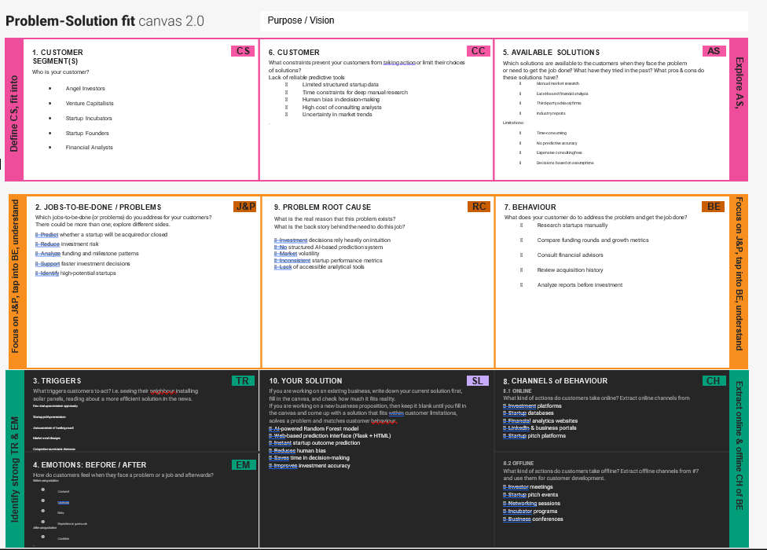

References:

1. <https://www.ideahackers.network/problem-solution-fit-canvas/>
2. <https://medium.com/@epicantus/problem-solution-fit-canvas-aa3dd59cb4fe>